**AADIKAVI BHANUBHAKTA CAMPUS**

Vyas-01, Damauli, Tanahun

**A Project Proposal on**

**QUICK HAJIRI: ATTENDANCE MANAGEMENT SYSTEM**



**Submitted By:**

**BIPANA RANA**

**BISHAL RUCHAL**

**DHAN BAHADUR ALE**

**LATIKA SUNAM**

*In partial fulfillment of the requirements for the degree of Bachelor of Information and Communication Technology in Education at Tribhuvan University*

**Submitted To:**

**Er. Ghan Bahadur Thapa**

**Department of BICTE**

**(May, 2024)**

# 1. Introduction

‘Attendance Management System’ is web-based application for maintaining the attendance of the student on the daily basis in the academic area. Here the teachers, who are handling the subjects, will be responsible to mark the attendance of the students because attendance is a baseline factor in determining student success. Each teacher will be given a separate username and password based on the subject they handle. An accurate report based on the student attendance is generated here. This system will also help in evaluating attendance eligibility criteria of a student. Report on the students’ monthly attendance is generated.

In today’s fast-paced educational environment, the need for efficient and accurate attendance tracking is more critical than ever. Traditional methods of taking attendance, such as manual input of attendance in registers are time-consuming in nature and susceptible to error. To address these challenges, we propose the development of a web-based Attendance Management System (AMS). This system controls the power of web technologies to streamline the process of capturing, managing, and reporting attendance data. By offering a centralized platform accessible from any internet-enabled device, our AMS aims to enhance the accuracy and efficiency of attendance management, benefiting administrators, teachers and students.

# 2. Problem Statement

The existing methods of tracking student attendance, such as manual paper-based systems or basic spreadsheet applications, often result in inefficiencies and inaccuracies. These methods are susceptible to human error, leading to inconsistencies in attendance records. Educational institutions face the challenge of maintaining accurate attendance records to submit with regulatory requirements and to assess the overall performance of students. To overcome these challenges, there is a need for a comprehensive Attendance Management System that automates the attendance tracking process, reduces the likelihood of errors, and provides administrators, teachers, and student with real-time access to attendance data. The system should be user-friendly, scalable, and capable of generating reports to facilitate data-driven decision-making for both academic and administrative purposes. By addressing these issues, the Attendance Management System aims to enhance the overall efficiency, transparency, and accountability of attendance tracking in educational institutions.

# 3. Objective

The Attendance Management System aims to automate and streamline the attendance management system process in educational institutions, ensuring efficiency and accuracy. It will involve providing real-time access to attendance records and simplifying the leave request process. It will enhance data security, generate detailed reports, and improve communication among students, teachers and administrators.

**3.1 Primary Objectives:**

1. To develop an automated system to capture student attendance through image recognition.
2. To verify student presence through image recognition.
3. To ensure attendance system seamlessly integrates with subject schedule.

**3.2 Secondary Objectives:**

1. To enable real-time access to attendance records for administrators, teachers and students.
2. To simplify the process of applying for and managing leave requests.
3. To ensure secure storage and easy retrieval of attendance data.
4. To provide comprehensive attendance reports.
5. To enhance communication between administrators, teachers and students regarding attendance and leave status.

# 4. Scope and Limitation

**4.1 Scope**

The main purpose of this project is to provide a reliable, secure, efficient and user-friendly environment to track attendance in educational institutions. The system will manage user profiles for administrators, teachers and students and enable seamless registration and maintenance of personal information and attendance records. It will facilitate automated attendance capture through a user-friendly web-interface, providing time updates accessible to all stakeholders. Additionally, the AMS will manage the leave process by allowing teachers to review and approve or deny the leave request, while students apply for leave online and view the status of their requests. The system will be accessible from any internet-enabled device, ensuring ease of use and accessibility across desktop, laptop, tablet and smartphone.

**4.2 Limitation**

In the geographically country like Nepal, internet connectivity isn’t reliable everywhere which is a critical limitation, as poor or no internet access can hinder the system’s functionality and affect performance. The accuracy of automated attendance capture is based on the quality of input data, there is an inherent margin of error in any automated process. The educational institutes with limited technological resources may face challenges in implementing the system efficiently.

# 5. Methodology

## 5.1 Requirement Identification

### 5.1.1 Study of existing system

* **Basic Spreadsheet Application**

Attendance is recorded in digital spreadsheets (e.g. Microsoft Excel). Manual data entry in digital spreadsheets still leads to errors. The attendance records are typically stored on individual computers which has the limited accessibility. These spreadsheets don’t provide real-time updates, which make it difficult to track attendance promptly.

* **Digital System**

A simple database applications or software is used to record attendance. It improves data storage and retrieval over manual and spreadsheet methods. The system like Mitra ERP, Veda Guru has advanced features such as takes attendance, real-time updates and comprehensive reporting. This system is scale well for larger institutions with large numbers of students and classes. But comparing the digital system with our attendance management system, our system automated attendance capture within less time interval and enhance communication through integrated featured for attendance and leave management.

* **Biometric System**

Using biometric scanners (fingerprint) to track attendance reduce the manual effort. Automated attendance capture reduces manual effort. It enhances security and verification. This system is being used in renowned institute mainly because it requires significant initial investment in hardware and installation. It can be affected by hardware malfunctions or technical issues. The visit of biometric system enhances our attendance management system to be more flexible and accessible across multiple devices with less initial investment.

### 5.1.2 Requirement Collection

* **Interviews**

We conducted interviews with administrators from the educational institutes to gain an understanding of the complexity of their attendance systems. We learned a great deal about the procedures in place, the difficulties that exist, and what is expected from a new attendance management system from these discussions. These realizations shaped our system design methodology and helped us discover important needs.

* **Observations**

We were able to observe directly the real-life execution of attendance processes in schools by conducting on-site observations. We determined problems, inefficiencies, and opportunities for improvement by watching the day-to-day activities and interactions with the current systems. Context-rich insights were gained from these observations, highlighting the significance of creating an attendance management system that is more effective and integrated.

* **Surveys and Questionnaires**

We created online quizzes and surveys to enhance the information we learned during the interviews. We were able to get organized input from a larger group of stakeholders—administrators, teachers, and students—thanks to these technologies. We made sure we had an accurate understanding of client needs by using these surveys to collect unique preferences and requirements, which helped direct the creation of a customized attendance tracking system.

* **Document Analysis**

We performed a detailed review of relevant research and literature in addition to directly contacts and observations. Through the examination of academic articles, and research papers, we were able to get a greater understanding of the wider context of attendance management systems in educational environments. We were able to discover prevalent issues, new trends, and best practices thanks to this study, which also offered insightful advice on how to create a creative and functional attendance tracking system.

### 5.1.3 Requirement Analysis

There are two types of requirement analysis i.e. functional requirement and non-functional requirement.

**5.1.3.1 Functional Requirement**

The most important stakeholders along with a short outline of their most important functionalities are the following:

1. User: User of the system in three different roles: Admin, Teacher and Student.

2. Admin

2.1 Login

2.2 Manage student

2.2.1 Add the student with their attributes

2.2.2 Update the student records

2.2.3 Delete the student records

2.3 Manage teacher

2.3.1 Add and save attributes for teacher

2.3.2 Update the teacher records

2.3.3    Delete the teacher records

2.4 Manage faculty

2.4.1 Add and save attributes of faculty

2.4.2 Update the faculty records

2.4.3    Delete the faculty records

2.5 Upgrade Semester

2.6 Manage subject

2.6.1 Add and save attributes of subject

2.6.2 Update the subject records

2.6.3    Delete the subject records

2.7 Manage attendance

2.7.1 View all the attendance records

2.8 Logout

3.Teacher

3.1 Login

3.2 View leave request submitted by student

3.3 Activate the device’s camera

3.4 Capture an image using the activated camera

3.5 Take attendance using the captured image

3.6 View attendance records

3.7 Logout

4. Student

4.1 Login

4.2 View attendance report

4.3 Send leave request to the teacher

4.4 Logout

**5.1.3.2 Non-Functional Requirement**

* **Performance:**

The system will process and display attendance records fast. The image capture and face recognition process will complete in minimal downtime.

* **Scalability:**

The system will handle the user and database without performance degradation.

* **Usability:**

The system will have an intuitive and user-friendly interface that is easy to navigate and ensures a smooth user experience.

* **Security:**

The system will implement role-based access control to ensure users can only access functionalities and data relevant to their role.

* **Reliability:**

The system will be reliable, provide data backup and recovery options to prevent data loss in case of system failure.

* **Compatibility:**

The system will be compatible with major web browsers, and support access from various devices, including desktops, laptops, tablets, and smartphones.

* **Data Integrity:**

The system will validate all data inputs to prevent incorrect or incomplete data entries, maintain data consistency across all modules and databases.

## 5.2 Feasibility Study

Feasibility study is the process of determining if a project is worth doing. The contents and recommendations of this feasibility study helped us as a sound basis for deciding how to lead the project. It will help in taking decisions such as which software to use, hardware combinations, etc.

### 5.2.1 Technical Feasibility Study

Technical feasibility is concerned with specifying equipment and software that will satisfy the user requirement. During the research of Attendance Management System, we conduct that the system is technically feasible because all the technical aspects of the system are available throughout our research.

Hardware Specification

* Processor: Intel Core i3-7100U
* RAM: Minimum 4GB
* Hard Drive: SSD or HDD minimum 128GB

Software Specification

* HTML 5
* CSS 3(Cascading Style Sheets)
* SQLite 3.37
* JavaScript ES14
* React Js
* Spring Framework
* Spring Boot
* OpenCV 4.8.1
* Figma
* Git
* Draw i.o
* Team Gantt

### 5.2.2 Operational Feasibility Study

Operational feasibility refers to projecting whether the system will operate and be used once it is installed. This system is operationally feasible since it will provide users with a straightforward user interface. Anyone with a basic understanding of our system can complete tasks by interacting with the displayed clickable buttons. The system will be dependable, user-friendly, maintainable, and cost-effective. The system is tested under various conditions with varying inputs ranging from a unit approach to an integrated approach.

### 5.2.3 Economic Feasibility Study

Since our system does not use any other extra or exceptional hardware components, it will be cheap and economically efficient.

* **Cost Estimation**

Cost Estimation depends on various factors such as the scope of the project, complexity of system requirements, development resources and implementation timeline.

|  |  |  |  |
| --- | --- | --- | --- |
| S.N. | Cost Categories | Estimated Cost | Frequency |
| 1. | Paper print Cost | 4,000 | One Time |
| 2. | Development charge per person | 4*5000 = 20,000 | One Time |
| 3. | Hosting and Domain | 500*12 = 6,000 | Annual |
| 4. | User Support and Maintenance | 5,000 | Annual |
| 5. | Training | 2,000 | Annual |
|  | Total | 37,000 |  |

Table 1: Cost Estimation

* **Cost Feasibility**

Cost Feasibility involves evaluating whether the costs associated with a project are justified by the expected benefits and returns. Cost Feasibility analysis include Payback period and Return on investment(ROI). They are:

**a) Payback Period**

Payback period refers to the time it takes to recover the initial investment made in implementing the system through the generated benefits or cost savings.

Net Annual Cash Inflow = Total Annual Cash Inflows −Total Annual Cash Outflows

= 65,000 – 12,000

= 53,000

Payback period = initial investment / net annual cash inflow

=37,000 / 53,000

= 6 months

**b) Return on Investment**

The return on investment (ROI) is a financial metric used to evaluate the profitability of an investment relative to its cost. It measures the percentage return or profit generated from an investment over a specific period of time.

ROI = (Net profit / initial investment) * 100

Here,

Net profit = Net annual cash inflow (53,000) – Initial investment (37,000) =16,000

So, ROI = Net profit / initial investment * 100

= 16,000 / 37,000 * 100

= 43.24%

Since, ROI is positive which indicates that the project is generating profits. Therefore, higher ROI signifies a better return relative to the initial investment.

## 5.3 Tools Used

### 5.3.1 Analysis and Design Tools

1. **Unified Modeling Language (UML) Tools**

We will employ UML tools to create various diagrams such as Use Case Diagrams, Entity-Relationship (ER) Diagrams, Sequence Diagrams, Class Diagrams, and Activity Flow Diagrams. These diagrams will help in defining system requirements, modeling data structures, and illustrating the behavior of the system.

1. **Wireframing Tools (Figma)**

Figma will be utilized to create prototypes of the user interface, aiding in visualizing the layout, navigation, and interaction flow of our attendance management system. This will ensure that stakeholders have a clear understanding of the system's design before implementation begins.

1. **Prototyping Tools (Figma)**

Figma will also serve as our prototyping tool, enabling the creation of interactive and high-fidelity prototypes of the system's user interface. These prototypes will facilitate user testing and feedback gathering during the design phase, ensuring that the final system meets user needs and expectations.

1. **Version Control Systems (Git)**

Git will be essential for managing and tracking changes to source code, documentation, and other project artifacts. It will enable collaboration, code sharing, and version tracking among our development team, ensuring that everyone is working with the latest and most up-to-date project files.

1. **System Design Tools (Draw.io, Team Gantt)**

Draw.io and Team Gantt will be utilized for system design purposes. Draw.io will help in creating various diagrams and visual representations of system components, while Team Gantt will assist in project scheduling and task management, ensuring efficient project planning and execution.

### 5.3.2 Implementation Tools (Frontend, Backend)

**a. Front End Tools**

1. **HTML 5**

HTML 5 is the latest version of the Hyper-Text Markup Language, the standard markup language for creating web pages and web applications. It will be used to structure the contents of the AMS web pages.

1. **CSS 3**

CSS 3 is the latest evolution of the Cascading Style Sheets language, bringing new features and capabilities to enhance the presentation layer of web pages. It will ensure a visually appealing and user-friendly interface across various devices.

1. **JavaScript ES14**

JavaScript ES14, also known as ECMAScript 2023, is the latest version of the JavaScript programming language, offering new syntax and features for better performance and developer productivity. It will enable dynamic content updates, form validations, and client-side logic

1. **React.js**

React.js is a JavaScript library for building user interfaces, particularly single-page applications, using a component-based architecture. React.js will be used to develop the front-end components of the AMS.

**b. Back End Tools**

1. **Spring Framework**

The Spring Framework is a comprehensive framework that will be used to develop the backend logic of the AMS. Spring MVC will handle HTTP requests and responses, while Spring Data will simplify data access operations.

1. **Spring Boot**

Spring Boot is an extension of the Spring Framework that simplifies the setup, configuration, and deployment of Spring applications, offering a convention-over-configuration approach.

1. **OpenCV 4.8.1**

OpenCV (Open Source Computer Vision Library) 4.8.1 will be used for the image recognition component of the AMS. It will enable capturing and processing images to identify and verify student attendance through facial recognition.

# 6. High level design of Proposed System (Use case Diagram, System Flowchart and ER Diagram)

## 6.1 Use Case Diagram

A use case diagram is a visual representation of the interaction between users (or actors) and a system. It helps to capture the functional requirements of a system and shows what the system will do from the perspective of the user.

## 6.1 Use Case Diagram

A use case diagram is a visual representation of the interaction between users (or actors) and a system. It helps to capture the functional requirements of a system and shows what the system will do from the perspective of the user.

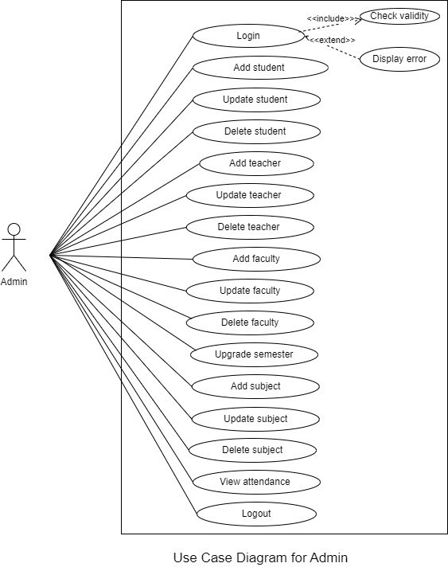

Figure 1: Use Case Diagram of Admin

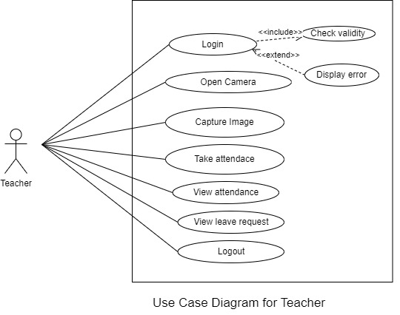

Figure 2: Use Case Diagram of Teacher

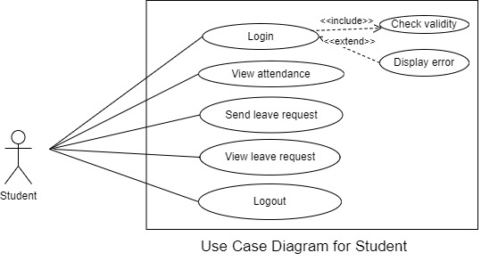

Figure 3: Use Case Diagram of Student

## 6.2 System Flowchart

## A system flowchart is a graphical representation of the sequence of processes, decisions, inputs and outputs within a system. System flowcharts are crucial for analyzing, designing, and documenting systems, facilitating clear communication among administrator, teachers, and students, and ensuring efficient system functionality.

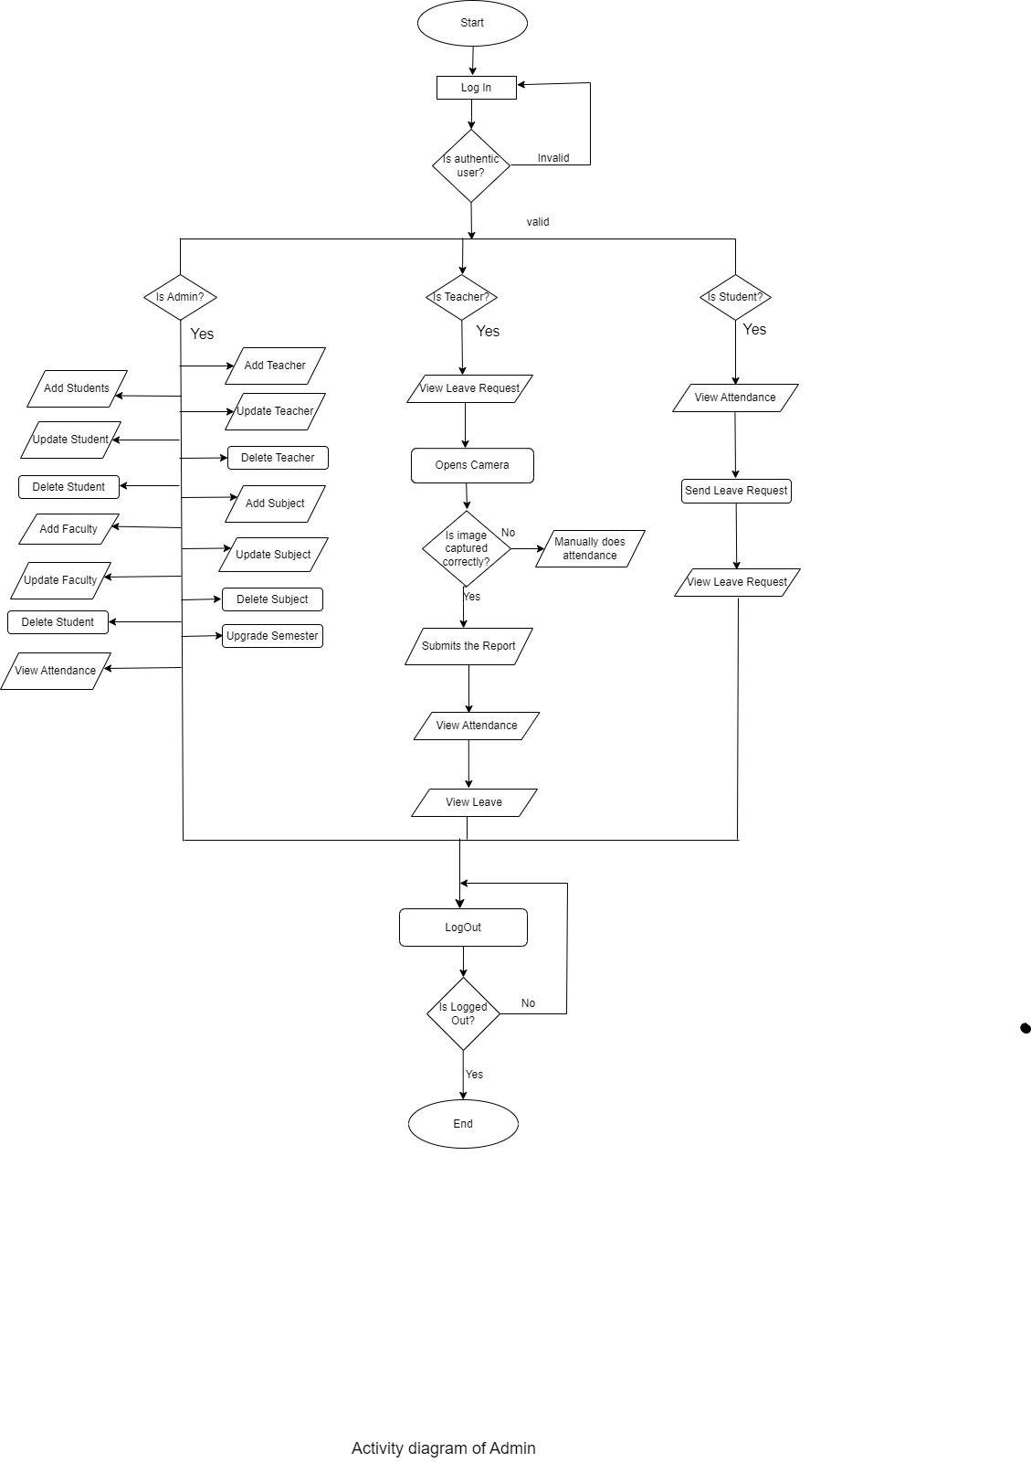

Figure 4: System Flowchart

## 6.3 Entity Relationship Diagram

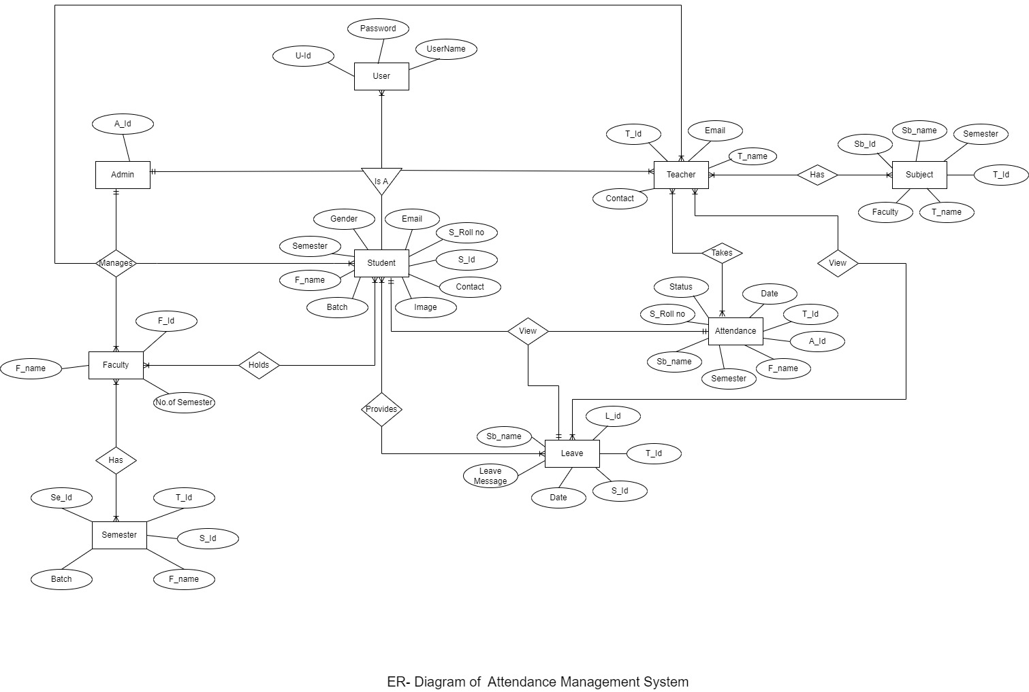An Entity-Relationship Diagram (ERD) is a visual representation of the entities within a system and the relationships between them. It is used in database design to illustrate data structure and relationships, ensuring data integrity and coherence.

Figure 5: ER- Diagram of AMS

# 7. Gantt Chart to show the projected time planning

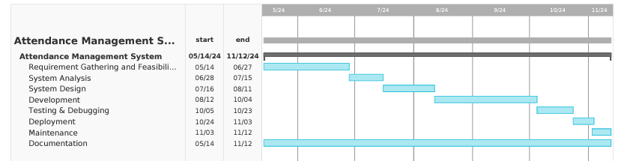A Gantt chart is a visual project management tool that illustrates a project schedule over time. It shows the start and finish dates of various elements of a project, allowing to see the overall timeline and the relationships between tasks.

Figure 6: Gantt Chart of AMS

## 7.1 Software Development Life Cycle

The Software Development Life Cycle (SDLC) is a systematic process used for developing software. It consists of several distinct phases, each with specific tasks and objectives.

|  |  |  |
| --- | --- | --- |
| **S.N.** | **SDLC Phases** | **No. of Days** |
| 1. | Requirement Gathering & Feasibility Study | 45 |
| 2. | System Analysis | 18 |
| 3. | System Design | 27 |
| 4. | Development | 54 |
| 5. | Testing & Debugging | 18 |
| 6. | Deployment | 9 |
| 7. | Maintenance | 9 |
| 8. | Documentation | 180 |

Table 2: SDLC Phases

# 8. Expected Outcome

The proposed Attendance Management System (AMS) will revolutionize attendance tracking in educational institutions by leveraging web technologies for accuracy and efficiency. By automating attendance capture through image recognition and providing real-time access to records, AMS will reduce human error and administrative workload. The system will offer a user-friendly interface, streamline the leave management process, and ensure secure data storage with role-based access control. AMS will be designed to be scalable and compatible across various devices, ensuring broad accessibility. The system will promise economic efficiency by utilizing readily available software and hardware. Ultimately, AMS will enhance communication among administrators, teachers, and students, improve operational efficiency, and support strategic planning through detailed insights, significantly improving the overall management of student attendance.